Project Design Phase Problem – Solu on Fit Template

Date | 5 February 2026
Team ID | Sanket Yadav, Shreyash Nimbalkar, Parth Jadhav, Mayur Dhole
Project Name | Strategic Product Placement Analysis: Unveiling  Sales Impact with Tableau Visualiza on
Maximum Marks | 2 Marks

Problem – Solu on Fit Template:
The Problem-Solu on Fit simply means that you have found a problem with your customer and that the solu on you have realized for it actually solves the customer’s problem. It helps entrepreneurs, marketers and corporate innovators iden fy behavioral pa erns and recognize what would work Purpose:
❑ Solve complex problems in a way that fits the state of your customers.
❑ Succeed faster and increase your solu on adop on by tapping into exis ng mediums and channels of behavior.
❑ Sharpen your communica on and marke ng strategy with the right triggers and messaging.
❑ Increase touch-points with your company by finding the right problem-behavior fit and building trust by solving frequent annoyances, or urgent or costly problems.
❑ Understand the exis ng situa on in order to improve it for your target group.
Template:
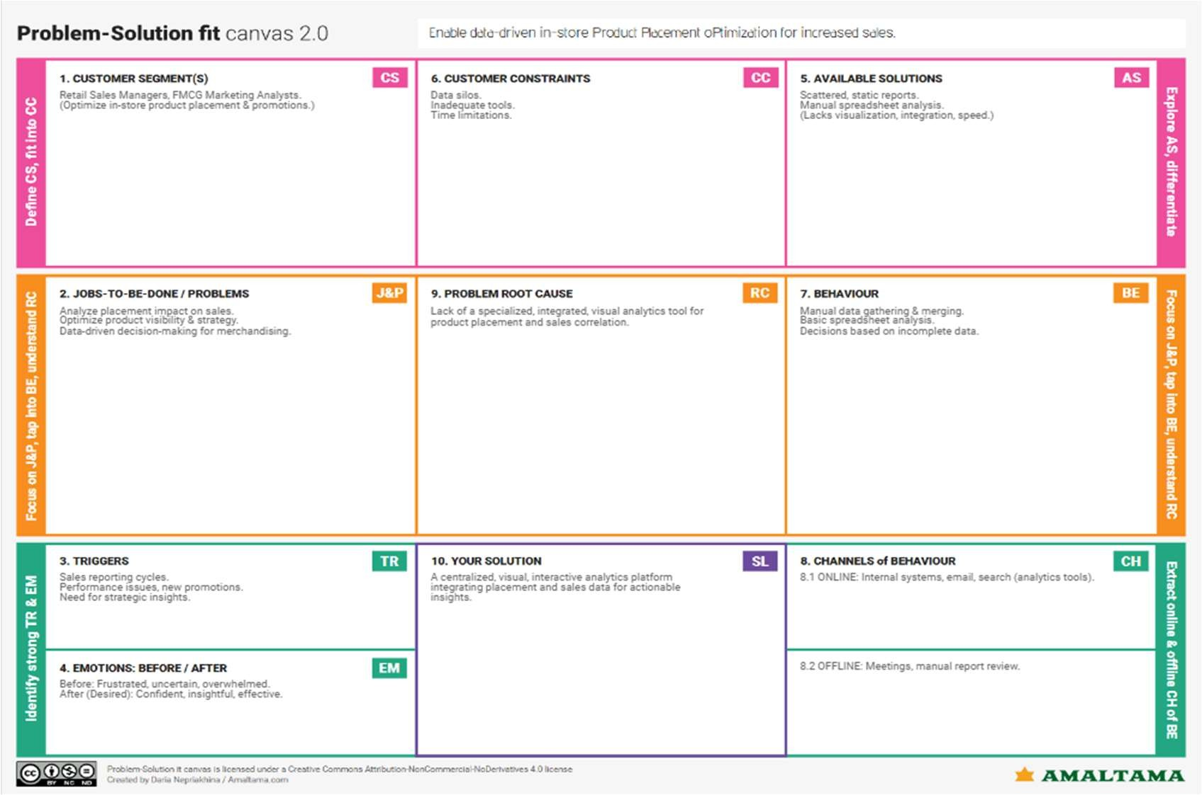
References:
- h ps://www.ideahackers.network/problem-solu on-fit-canvas/
- h ps://medium.com/@epicantus/problem-solu on-fit-canvas-aa3dd59cb4fe

